Cycling Strategy for Harrow
2015-2018
Incorporating Cycling Policies and Action Plan

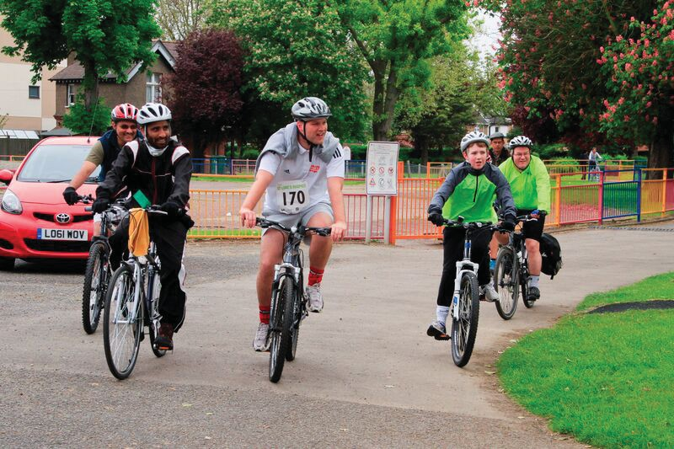
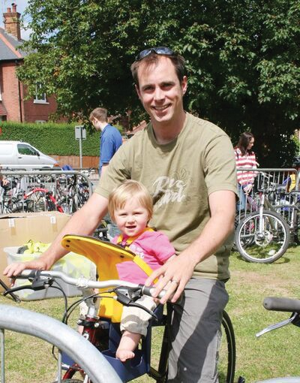
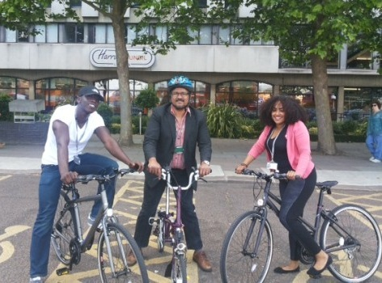
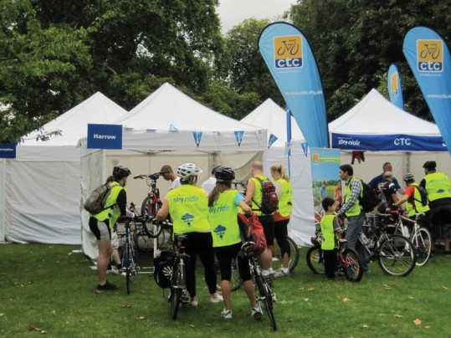
1 Introduction 4
1.1 Overview 4
1.2 Context of the Strategy 4
1.3 The Mayor’s Vision for Cycling 6
1.4 Consultation 7
1.5 Reference Documents 7
2 Current and Aspirational Cycling Infrastructure 8
2.1 Existing Cycling Infrastructure 8
2.2 The Aspirational Cycling Infrastructure for Harrow 8
3 Need for the Borough Cycling Strategy 10
3.1 Establishing Need 10
3.2 Overcoming the Barriers 17
3.3 Integrating cycling into Borough Planning and Development initiatives 20
4 Borough Cycling Strategy 21
4.1 Structure 21
4.2 Vision Statement 21
4.3 High Level Cycling Objectives 21
4.4 Harrow Cycling Policies 22
5 Funding of cycling schemes 25
6 Working in partnership 25
7 Borough Cycling Targets 25
8 Delivering the Strategy 28
8.1 Borough Cycling Action Plan 28
8.2 Borough cycling implementation plan 29
8.3 Monitoring of the Action Plan 29

APPENDIX A Existing Cycling Infrastructure Map
APPENDIX B Existing Cycle Parking Map
APPENDIX C Aspirational Cycling Infrastructure & Cycle Quietways map
APPENDIX D Cycling Policies in the Harrow Sustainable Transport Strategy
APPENDIX E Linking Borough Cycling Targets to Cycling Policy
APPENDIX F Borough Cycle Action Plan
APPENDIX G Borough Cycle Implementation Plan
APPENDIX H Borough Cycling Monitoring Action
FORWARD

I’m delighted that Harrow is transforming into a Cycling friendly Borough.

This Cycling Strategy focuses on providing quality facilities and supporting infrastructure to ensure that our roads are safe for pedestrians and cyclists, and to reduce traffic on our roads.

Spurred on by all of our recent sporting successes, cycling is becoming increasingly popular. With the range of benefits it brings, from health and environmental, to being a cheaper way to commute to work, we want to do everything possible to get residents cycling.
As a Council we have invested significantly into cycling over the years on a range of initiatives, such as cycling lanes, and just recently our piloting of the Brompton Cycle Hire for Council staff. We are also firmly in support of all the work done by local volunteering groups to promote cycling within the Borough, including the work done by Harrow Cyclists and Breeze to get more women cycling.

I would like to thank all our staff and partners who have done so much work to bring this strategy together and I hope that this is just the beginning of our work to make Harrow a cycling friendly Borough.

Cllr David Perry
Leader of Harrow Council

Introduction

Overview

Harrow Council recognises the role of cycling both as a sustainable transport mode and a leisure activity. The Council has therefore included consideration for cycling and the need for good quality and safe cycling infrastructure in the Council’s transport policies and delivery plans.

Cycling is recognised as a key sustainable transport mode in the Harrow Local Implementation Plan, which outlines the Councils approach to delivering the Mayor’s Transport Plan. Funding for cycling schemes and initiatives have been included in the three-year programme of investment to help meet the targets and outcomes that the Borough is seeking to achieve.

The Harrow Sustainable Transport Strategy, published in 2013, sets out our commitment to encourage a greater take up of walking, cycling, scooting and public transport usage and how each of the sustainable travel modes are managed in the borough.

This document brings together all the policies and targets relating to cycling that are referred to in these documents into one overarching strategy document for cycling in the Borough. This will give transparency to the Councils cycling programme with a clear vision and a commitment to improve and increase cycling in the Borough.

Context of the Strategy

This Harrow Cycling Strategy supplements and supports the Council’s Vision and earlier documents relating to or which make reference to cycling by Harrow Council.

Meeting Harrow’s Vision: -

The Cycling Strategy will meet the Council’s vision for Harrow: a place to live and work and be proud of. This vision will be delivered by making a difference:

- For the vulnerable
- For the communities
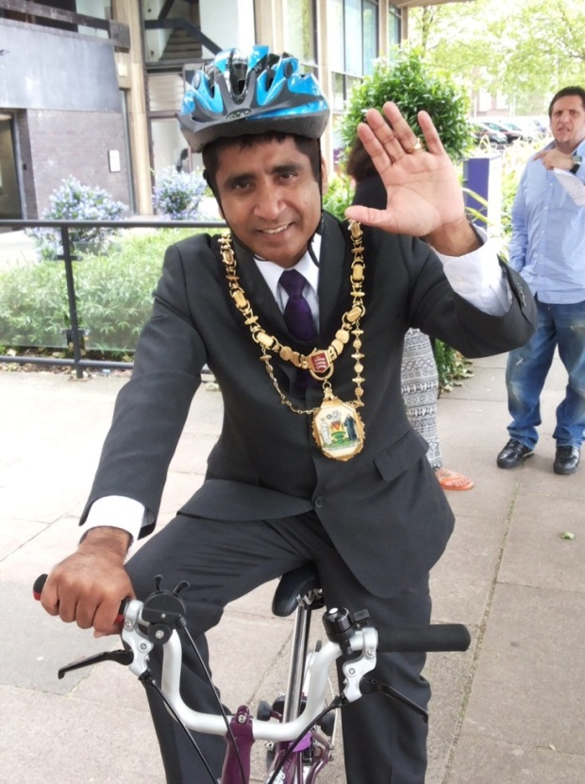

Cycling across London is transforming rapidly with more and more people choosing to cycle for work, leisure or sport. The growth in cycling is supported by new and innovative programmes promoted across London such as the Santander Bike Hire, Cycle Superhighways and more recently, Cycle Quiet ways and Mini-Hollands. There are also numerous private sector initiatives such as Brompton Bike Hire that now provide Londoners access to a bicycle without owning a bike. Traditional approaches of dealing with and planning for cycling will need to recognise and embrace these changes.
The Strategy will steer Harrow Council’s proposals and implementation plans in the short and medium term. This strategy will be subject to an interim review at end of 2016/17 and an update if a new Transport Plan is issued by a future Mayor of London.

There are significant pressures driving this strategy:

Growing population - Over the next decade, Harrow’s population will continue to rise and the average household size will decrease. According to the West London sub-regional transport plan, in Harrow additional housing projected is 350 houses per year until 2021. This is less than neighbouring boroughs, but still significant. The new population will also require access to a range of employment, schools, health, retail, leisure and other infrastructure and this will generate demand for travel in line with the rise in population. However, due to a lack of available space, providing additional capacity on the road network other than by making small changes at junctions and other adjustments to existing highway space to deliver small efficiencies would be impractical and expensive. Major public transport investment is long-term and costly even if projects are brought forward, and not all can provide adequate additional capacity by the time they are completed.

Growth in demand for motorised modes of ravel - It is expected that growth in demand for motorised travel would outstrip the available supply of land for transport and in any case numerous studies show that building new infrastructure induces more travel demand including on routes that are meant to be relieved. Travel generally, particularly by car, would become even more difficult without measures to spread demand across a wider range of mode choices. Making the most of the potential offered by all modes of transport including cycling is therefore an important facet of a well-managed transport system. A new approach is needed in the borough to address congestion by widening the choice of modes of transport that are available to people.

Harrow’s road and public transport network are already under pressure with severe congestion on a daily basis particularly at Harrow town centre and district centres.

Health and wellbeing: - Not everyone can cycle and not every journey can be cycled, but significantly increasing the number of people who decide to take up cycling for more of their journeys will help to ease, or at least reduce, the difficulty of travelling by car or bus in the borough.

Reducing additional pressure on our already congested network by increasing levels of cycling is one important way in which the investment will benefit everyone in Harrow even if they would never contemplate cycling.

Cycling has considerable scope for growth and it is, for many, the best way of making short journeys of up to 5 km (3 miles) at lower infrastructure costs compared to other modes of transport
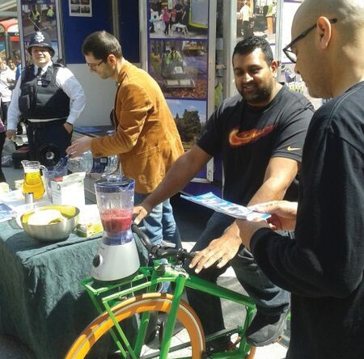

Encouraging cycling can help to meet a range of health, sustainability, social, economic and environmental objectives, and even has benefits for non-cyclists. Transferring from other modes to the bicycle can ease congestion on the roads, rail, tube and buses, freeing up more capacity for everyone else, whilst helping to sustain growth in population and jobs and improving air quality and public health. In the current economic climate, offering people a viable way of travelling around at minimal cost to access jobs, education, health and other services is also an important goal. Also, encouraging more people to incorporate active travel into their everyday routine could significantly improve the health of all with associated long-term savings to be made in terms of public health and for businesses.

The Mayor’s Vision for Cycling

Two thirds of London’s cycling potential (based on population analysis) exists in outer London where about half of all car trips are less than 2km and public transport provision is not as comprehensive as in Central London.

In March 2013 the Mayor of London launched a Vision for Cycling in London, which highlights an ambition to see cycling ‘normalised’ by encouraging a broader cross section of people to take up cycling. It set out four key outcomes:

- a “tube network” for the bike;
- safer streets for the bike;
- more people travelling by bike; and
- better places for everyone.

This vision will be delivered using an estimated budget of £913m over the next 10 years, a proportion of which will be made available to boroughs to help deliver the vision.

These schemes will build on the recent growth in cycling, which has increased by 107 per cent on London’s major roads between 2000 and 2008.
.
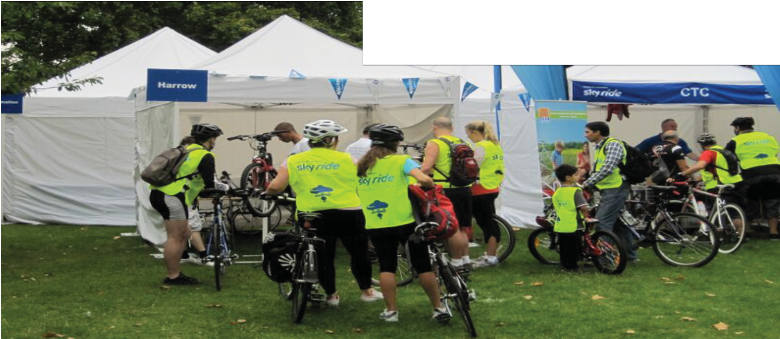

Consultation

The Harrow Cycling Strategy has been developed in consultation with Harrow Cyclists. We are grateful to Transport for London for strategy development guidance and to Harrow Cyclists for valuable feed- back.

Reference Documents

Context for this strategy is provided by London wide and Council policies relating to cycling, in particular the Mayor’s Transport Strategy and Vision for Cycling in London, West London Cycling, the Harrow Sustainable Transport Strategy and Local Implementation Plan as well as other guidance documents that have been specifically produced on cycling.

Reference is also made to the Get People Cycling Recommendations produced by the All Party Parliamentary Cycling Group.

The Mayor of London has set a target of a 400% increase in cycling on 2000 levels by 2026 to achieve an average 5% mode share across London, which would vary by region and borough.

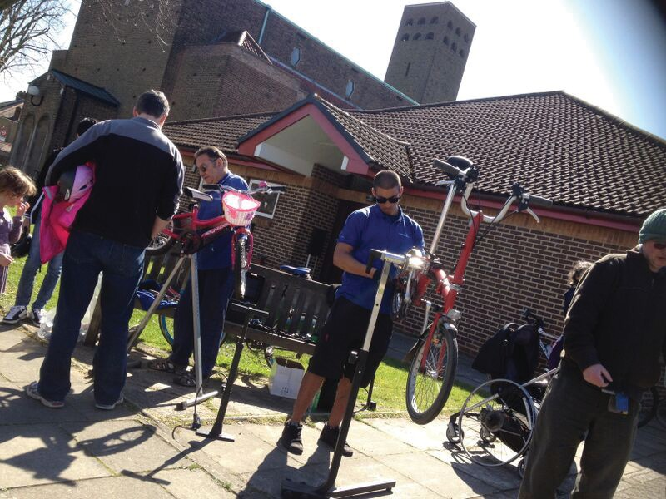
B.

Current and Aspirational Cycling Infrastructure

Existing Cycling Infrastructure

As of December 2014, there is 40.6 km of on-road cycle routes, 4.8 km of off-road cycle routes and 6.5 km of Greenway cycle routes in the Borough.

All existing cycle routes in the Borough are shown in Appendix A. The Ealing to Barnet route forms the main east-west route passing along Alexandra Avenue, Imperial Drive, Headstone Lane and Whitchurch Lane. North-south cycle routes provide connectivity between Harrow on the Hill town centre and other urban centres in the Borough.

The existing cycle network is integrated into the wider West London cycle network and provides some continuity of cycling to town centres located in adjacent Boroughs.

Harrow Council has prioritised the rolling out of cycle parking facilities across the Borough as a measure to encourage cycling. As of December 2014 there are 545 cycle parking stands at stations (124), shopping/commercial areas (369) and at other key locations (52). A further 127 cycle stands are expected to be installed by the end of 2014/15. The Borough Cycle Parking Location map is at Appendix B

The Aspirational Cycling Infrastructure for Harrow

Harrow Council recognises that more should be done to improve the quality of the cycle infrastructure, expand the cycle network and to create a seamless cycle link across the Borough. The realisation of a comprehensive cycle network in Harrow is constrained by funding availability which is currently allocated through the annual TfL LIP programme.
Harrow Council’s aspiration for a complete Borough-wide cycling infrastructure network is shown in Appendix C. The Council has been provided with LIP funding up to 2017 for improving 0.7 km of on-road and Greenway cycle routes respectively as shown. TfL have also expressed intent to fund 10.5 km of Quietways in the Borough but no confirmation has been provided on the implementation schedule as yet.

When completed, the aspirational cycle network will provide a seamless, convenient and safe cycling connectivity across the Borough and to key destinations at adjacent Boroughs. Figure 2.1 shows the schematic aspirational strategic cycle network for Harrow.

Figure 2.1 Harrow’s Aspirational Strategic Cycle Network

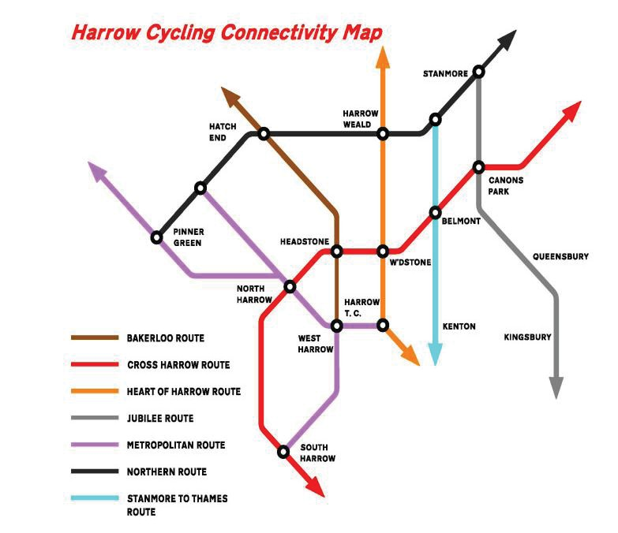

Need for the Borough Cycling Strategy

Establishing Need

The overarching reasons for the development of a cycling specific strategy for the Borough are as follows:

- It provides an opportunity to collate and crystallise the various documents and information on cycling to support funding requests;

- It sets out a structured methodology to enable prioritisation to take place in a transparent and robust way;

- It allows a re-prioritisation of funds to increase cycling and investment in cycling action plans; and

- It strengthens the Councils position to propel cycling into a dominant mode of travel in the Borough and across the sub region.

Harrow Council has ambitious targets in our current Local Implementation Plan to increase the mode share of cycling. With the support of the Mayor’s cycling funding on offer, our proposals of coordinated hard and soft measures will target potential cyclists of all age groups and backgrounds. Harrow has one of the most diverse populations of any London Borough which is a challenge to increasing cycling mode share, particularly with the limited existing cycling infrastructure.

Harrow Council recognises that cycling is an activity that addresses a variety of agendas, including health, transport, sport, community cohesion and more recently tourism. Harrow’s cyclists and local cyclist groups wish to see a more comprehensive cycling infrastructure that provides safe facilities for their whole journey i.e. an end-to-end approach.

It is the intention that this document provides the necessary framework to support the Council secure funding for cycling infrastructure and to steer the rolling out of supporting action to raise the benchmark for cycling.

Harrow has great potential to increase cycling to create a significant mode share for journeys. The 2011 Census identified that there is relatively low levels of cycling despite there being 41 km of cycle lanes in the borough linking key trip generators and places of interest such as stations, shopping areas, schools, open spaces etc.

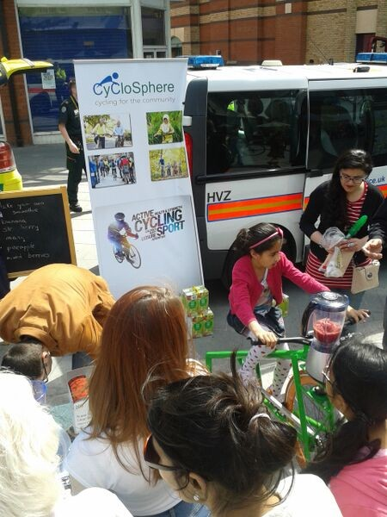

The relatively low levels of funding received by Harrow Council in recent years, compared to Central London Boroughs have only enabled us to make small, localised changes to the network to assist cyclists.

The Harrow LIP2 identified that Harrow residents may account for about 13% of the potentially cycleable trips in the west London sub-region. The West London Cycling Plan has identified that Harrow has the potential to achieve a 3% target of its population cycling. The Council is keen to respond positively to its role and responsibility to promote cycling to meet the Mayoral objective.

The promotion of cycling in the Borough is mainly motivated by the Council’s desire to improve public health, improve air quality, to reduce congestion and to reduce the impact of climate change for its residents and people who work and visit the Borough. As an interim target, the Harrow LIP has set a target of 1.5% mode share for cycling in 2013/14. Over the longer term, the Council is aiming to achieve the 5% modal share for cycling by 2026 as outlined in the Mayor’s Transport Strategy.

This is a significant challenge for Harrow where car ownership is high because of the geographical location of the borough on the outskirts of London. TfL estimates that there are 70,000 daily trips currently being undertaken by other modes in each Outer London borough that could be made by bike. If this were achieved, this would have a significant impact on the health of those cycling(6). Based on the 2011 Census(7), Harrow is also the Borough with the second highest percentage of households in London owning two or more cars at 33%. At the same time, 23% of all households in the Borough have no car or van which is lower than all London Boroughs except Hillingdon. The high car ownership that currently exists in Harrow is of considerable concern that may intensify as the population grows. There is also lower bus use in Harrow where car ownership levels are highest.

The strategy will need to include innovative and implementable measures that would support the Councils drive to encourage residents to cycle rather than to travel by private car.

The Council considers all projects that promote alternatives to the car to be to the benefit of increased social inclusion. This will take into consideration the unique aspect of Harrow’s ethnic and religious diversity, with more than half of its residents being from BAME groups. London Councils have reported that BAME road users are at higher risk of death or serious injury than non-BAME individuals across every mode except when travelling by bus and that BAME cyclists experience approximately twice the risk of non-BAME cyclists.

The cycling strategy will help the Council meet its equality obligations to ensure that cycling can be enjoyed and is accessible to all residents and visitors in Harrow.

Cycling is part of the Councils effort to encourage residents to live a healthier lifestyle and is a
major action to improve health.
The Council wants to encourage more cycling to deliver significant direct impact on personal health as part of its Borough wide concern for local health. Diabetes levels in the borough which correlate to obesity are estimated to be the highest in London and above the average for England.

The cycling strategy forms part of the Councils efforts to improve air quality and to reduce emissions generated by motorised vehicles. The Borough was declared an air quality management area (AQMA) in January 2002. Air quality modelling has identified road traffic as the main contribution to nitrogen dioxide concentrations and locations which experience the highest PM10 concentrations are mainly the result of emissions from motorised vehicles. An increase in cycling will reduce these emissions and improve air quality in the Borough.

We want to work with communities to mould the next generation of cyclists and to create greater awareness of cycling as a mainstream mode of transport.

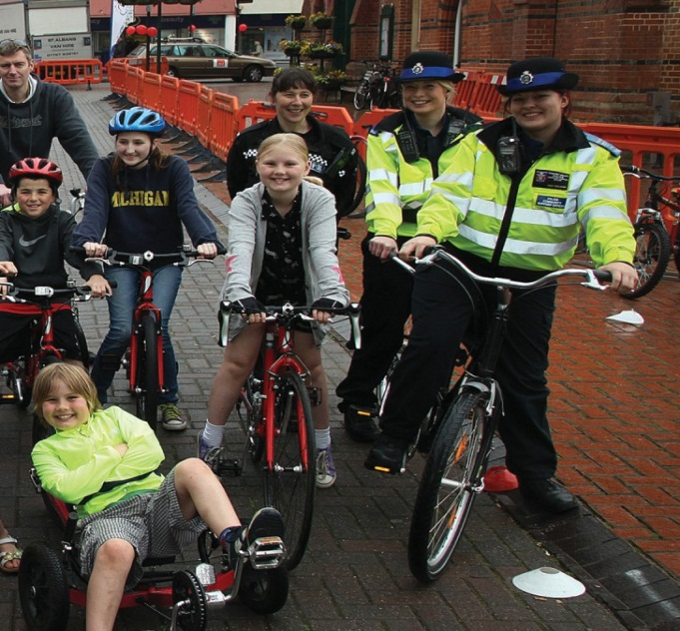

Our aim is to create the conditions in which those who rarely or never cycle at the moment because of fear of danger simply choose to start cycling for more journeys. In particular we want to enable parents to feel confident enough to allow their children to travel to school by bike either accompanied or independently. If successful, this will help to slow or even reverse worsening congestion caused by the school run. Creating the right environment for children to cycle safely will also make it easier for us to widen the demographic of cyclists to include more women, people from minority ethnic groups, older people and disabled people for whom the bicycle can bring greater freedom

Historically, Harrow has recorded low levels cycling in the Borough and lags behind other West London boroughs in terms of percentage of residents that cycle on at least two days a week as shown in Figure 3.1. This is why relatively high investment in cycling is needed in Harrow.

Figure 3.1 Percentage of residents who cycle on at least two days a week by borough of residence.

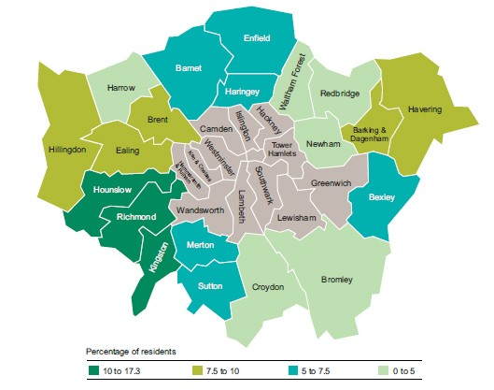

Figure 3.2 Number of potentially cycleable trips by borough

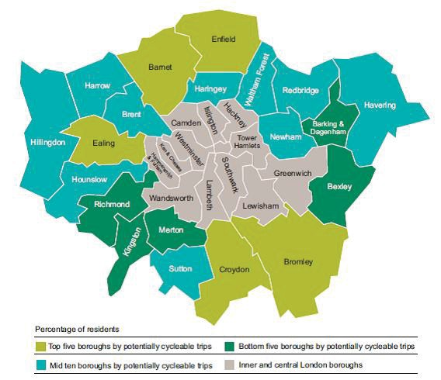

The current low cycling rate indicates that the Borough has a higher than average level of potential cycleable trips as shown in Figure 3.2. Hence compared to other West London Boroughs, the Council has a greater challenge to work with residents and cycling groups to raise the levels of cycling in the Borough.

Whilst there are both significant benefits to be gained and the potential for increasing cycling in Harrow, the process of delivering the change required to support and sustain growth is more complicated. This strategy recognises that there has been very little data collection and feedback on the barriers and challenges in encouraging more people to cycle in the Borough.

Figure 3.3 shows the main reasons that non-cyclists give for not wanting to cycle in London based on a 2013 TfL survey. We recognise that this is a generalised response for London and does not specifically address Harrow’s unique outer-London Borough characteristics.

Personal safety is a key concern and is a major issue that needs addressing to encourage more people to cycle. Citing age and physical inability to take up cycling emerged as the second most frequent reason. This is probably more relevant to Harrow where we have a large minority population who tend to perceive cycling as an activity for the younger members of their community. The response that other modes work better for me is more difficult to address as this implies a high degree of comfort with their current mode of travel. There is a need to raise awareness that travelling by car is not always better to alternative modes considering the cost of travel, greater environmental and congestion impacts and journey time reliability.

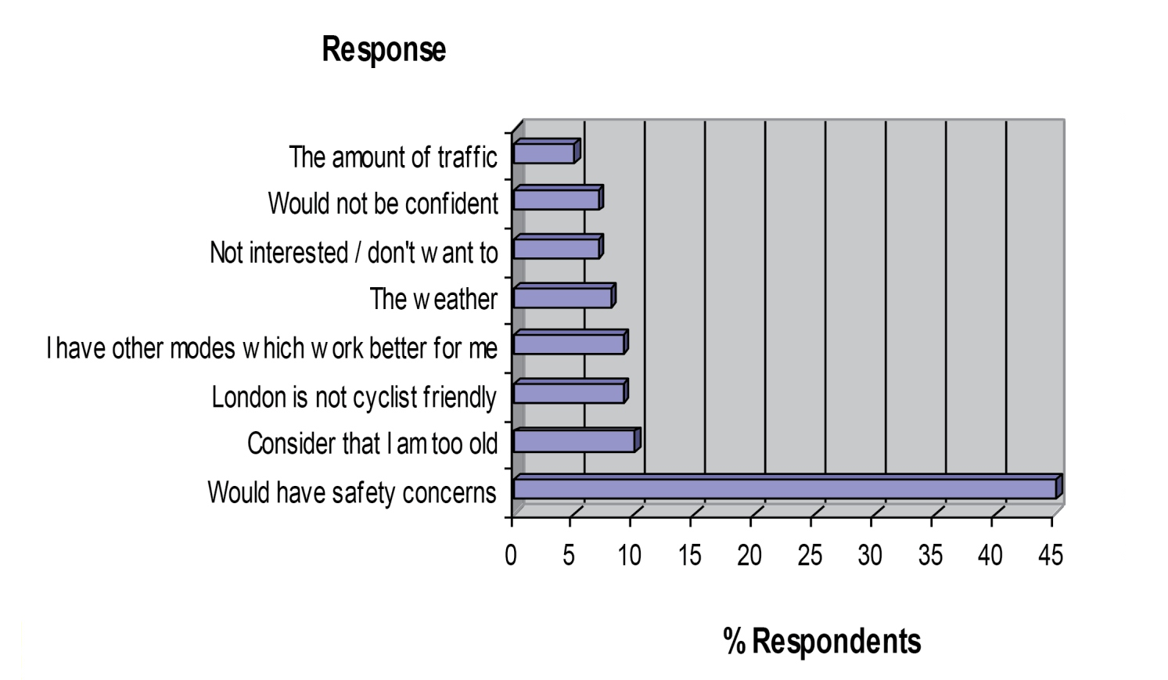

Figure 3.3 Reasons given by non-cyclists for not wanting to take up cycling in London – Source TfL Survey

Harrow Council has a priority to ensure that the transport networks are safe for use by all users particularly pedestrians and cyclists. The cycle network at Harrow will not only need to be safe but also be perceived to be safe by cyclists. The survey results suggest that there is a continuing need to build confidence in cycling across all levels of society and to promote the message that almost anyone can become a competent and regular cyclist, through training, education and regular engagement activities.

The Borough recognises that just as with motivational factors for cycling, key barriers will vary between different segments of the population. The Delivering the Benefits of Cycling in Outer London Borough report identified the following personal and organisational level barriers to cycling:

- An incomplete London Cycle Network (within and across Borough boundaries);

- Difficulty in obtaining funding for cycling improvements;

- Concerns about safety and high numbers of collisions in London involving cyclists: and

- Insufficient training, information and education.

More can be done to strengthen the continuity of the cycling network in Harrow and to adjacent boroughs.
This will have to take into consideration the lower density of the cycling network and potential cycleable origin and destinations trips compared with Central London as shown in Figure 3.4.

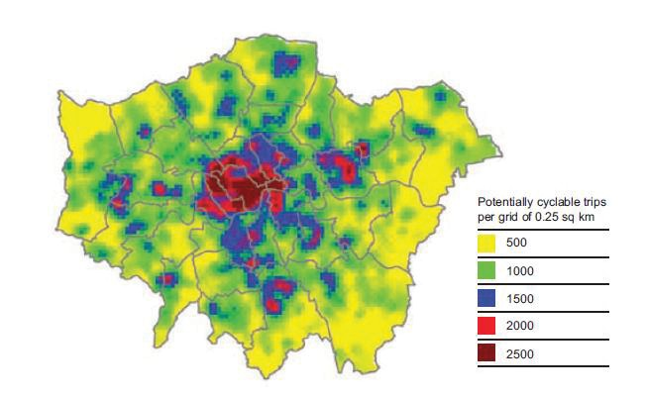

Figure 3.4 Potential Cycleable Trips in London by Trip Origin (Source: Delivering the benefits of Cycling in Outer London, London Councils)

The Borough has delivered significant levels of cycling infrastructure and supporting schemes to help raise the levels of cycling in the Borough.

Particular focus has been on road sections that pose a safety risk to cyclists particularly at roundabouts and road sections with high levels of peak hour traffic. In addition, funds have been spent where it is relatively low cost to install schemes, giving greater cost-benefit ratios. However, this has resulted in some sections of the Borough, having breaks in cycling infrastructure and hence does not enable continuous cycling across the Borough.

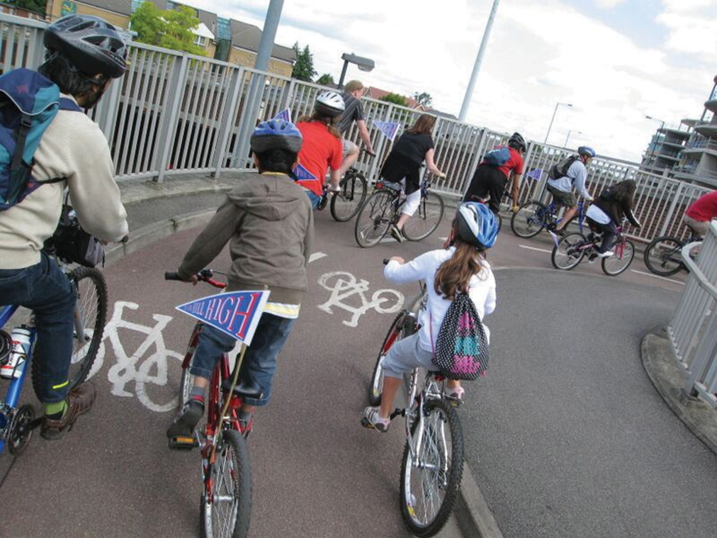

Overcoming the Barriers

The Borough Cycling Strategy will form the catalyst of all action taken by the Borough to overcome barriers to cycling, to increase cycling levels and to raise the profile of cycling as an important mode of transport in the Borough. This will be achieved by:

- Creating a safer and better environment that supports cycling as an equal mode of transport;

- Promote cycling as a convenient, safe, secure, inclusive and enjoyable activity;

- Elevating cycling as an important sustainable mode of travel in the Borough; and

- Facilitating and supporting bicycle ownership/access and secure parking

The strategy will strengthen and supplement current programmes with new initiatives to address the identified barriers to cycling in Harrow through identified actions.

The three groups of barriers are:

Attitudinal Barriers for Individuals
Physical Barriers
Barriers to Delivery
Attitudinal Barriers for Individuals:

- Fear of Traffic and feelings of vulnerability, particularly when undertaking unfamiliar journeys, convenience of the cars.

- Historically high reliance on car.

- Concerns over look and feel of cycling. Individual not sure cycling is for them.

- Lack of flexibility or spontaneity. Cycling perceived as incompatible with busy/complicated lifestyles.

Physical Barriers:

- Traffic speeds, driver behaviour.

- Insufficient cycle parking/cycle facilities at key locations

- Severance caused by major roads, gyrators, railways.

Barriers to Delivery:

- Requires greater political support and priority.

- Insufficient funding to deliver all aspirational schemes and improvements.

- Dedicated and experienced staff that is responsible for cycling at the Council.

A series of strategies have been identified to deal with the barriers. These are set out below:

Strategies To overcome attitudinal barriers for individuals

Strategies To Overcome Physical Barriers

Strategies To Overcome Delivery Barriers

Integrating cycling into Borough Planning and Development initiatives

More needs to be done to integrate cycling into planning and development initiatives that are taken forward in the Borough. There will be more joined up thinking across the various Directorates in the Council on delivering more for cycling.

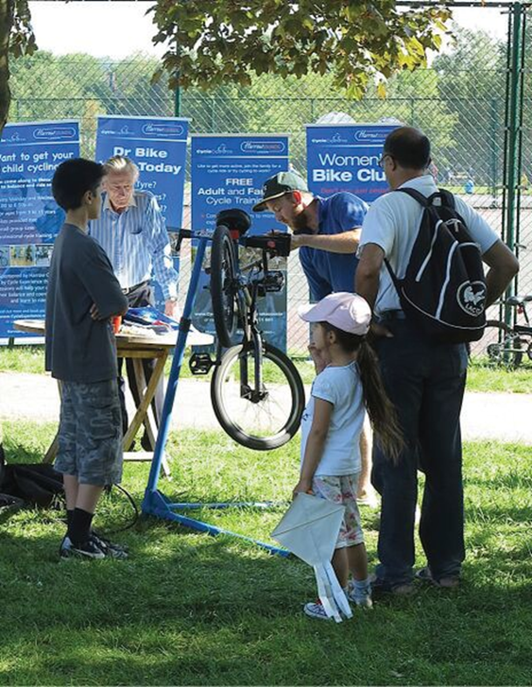

Borough Cycling Strategy

Structure

The Borough Cycling Strategy consists of the vision for cycling in the Borough, cycling objectives, cycling policy, the setting of targets, proposed action plan and monitoring plan.

It is intended that the strategy identify investigations and data collection that would help the Council make decisions on prioritising improvements to existing cycle schemes as well as on the delivery of aspirational cycle schemes.

Vision Statement
Harrow Cycling Vision Statement

“We want to increase the number of people cycling in the borough by making cycling more convenient, better connected, safer and more appealing to people from all backgrounds.

Cycling should be seen as an enjoyable, safe, practical and accessible everyday option for more people, including older and people with disabilities, children and families.”

High Level Cycling Objectives

Objective 1

The Council will create a safer and better environment that supports cycling as an equal mode of transport
Objective 2

The Council will promote cycling as a convenient, safe, secure, inclusive and enjoyable activity
Objective 3

The Council will elevate cycling as an important sustainable mode of travel in the Borough
Objective 4

The Council will facilitate and support bicycle ownership/access and secure parking

Harrow Cycling Policies

This Cycling Strategy makes reference as appropriate to the strategic Harrow cycling policies reported in the Harrow Sustainable Transport Strategy (HSTS). The HSTS policies listed in Appendix D underwent a borough wide public consultation and was then updated and agreed by Harrow Cabinet. The cycling policies in this Harrow Cycling Strategy supplements and strengthens the policies in the HSTS.

Policy P1: Create a safer and better environment that supports cycling as an equal mode of transport

Ref | Policy | Notes
P1.1 | The Council will ensure the progressive development and maintenance of a high quality cycle route provision, clear continuity and consistency in design; and will ensure that, wherever practicable, provision is designed and implemented to also cater for tricycle and trailer use (incorporates HSTS policy C10) | This would cover all infrastructure improvement plans
P1.2 | The Council will alleviate barriers to cycling by improving the bikeability of all routes in Harrow and ensure that routes are made suitable for entry level cyclists
P1.3 | The Council will ensure cycle routes and facilities in the borough are appropriately located and regularly cleaned and maintained and that whenever possible, cycle tracks in parks are available for use at all hours (incorporates HSTS policy C3)
P1.4 | The Council will work with TfL and other agencies to support the introduction of cycling schemes and initiatives and work towards becoming a biking borough (incorporates HSTS policy C9) | Includes the Mayors vision for cycling and other new cycling initiatives
P1.5 | The Council will introduce cycle infrastructure design standards across the Borough
P1.6 | The Council is committed to reducing the risk of collisions involving cyclist through good design, continuous monitoring of collision hotspots and working in partnership with enforcement and community groups. | Supports commitment to improving safety as the safest Borough in London
P1.7 | The Council will work in partnership with adjacent authorities to develop and to maintain high quality and safe cross-boundary cycling infrastructure

Policy P2: Promote cycling as a convenient, safe, secure, inclusive and enjoyable activity

Ref | Policy | Notes
P2.1 | The Council will provide cycle training for adults and children and for people with disabilities to create a confident and responsible cycling community in the Borough (incorporates HSTS policy C1) | Includes all cycle training and education programmes
P2.2 | The Council will introduce measures and programmes to encourage persons from BAME and other statistically cycling adverse groups to take up cycling and to cycle more often. | An Equality Impact Assessment is required for all cycle schemes.
P2.3 | The Council will promote the recreational use of cycling while giving priority to its aim of increasing cycling as an alternative to private car use (incorporates HSTS policy C2) | Needs to be linked to facilities being made available for use for extended periods
P2.4 | The Council will encourage the use of bicycles generally and in particular for journeys to school (incorporates HSTS policy C4) | Includes working with schools, children & young people.
P2.5 | The Council will encourage employers to make provision for employees wishing to cycle to a similar standard to that required from new development including the provision of “cycle pools” (incorporates HSTS policy C5) | Workplace travel plans, planning conditions and use of S106 funding
P2.6 | The Council will publish and make available cycling leaflets and maps in areas of the borough identifying the locations of designated cycle routes, cycle parking facilities, barriers to cycling and main road crossings (incorporates HSTS policy C6)

Policy P3: To elevate cycling as an important sustainable mode of travel in the Borough

Ref | Policy | Notes
P3.1 | The Council will ensure cycling is at the heart of our sustainable and inclusive policies as a “biking borough” for all
P3.2 | The Council will treat cycling and the needs of cyclists as an important mode of sustainable transport
P3.3 | The Council will consider the needs of cyclists as a core element in future regeneration programmes for local centres and employment areas.
P3.4 | The Council will support the development of cycling forums and cycle community groups | Link to Community, Planning, Economic Regeneration programmes
P3.5 | The Council will seek to secure funding for cycling through alternative funding sources outside the LIP programme

Policy P4: To facilitate and to support bicycle ownership/access and secure parking

Ref | Policy | Notes
P4.1 | The Council will use its powers and resources as local planning authority to make planning permission for future development conditional upon the availability of an appropriate level of cycle parking and facilities such as showers and lockers and encourage provision of “cycle pools” (incorporates HSTS policy C7) | Should be considered as part of Planning and Economic Regeneration conditions
P4.2 | The Council will use its powers and resources to provide secure and weather-protected cycle parking at sites generating/attracting significant numbers of cycling trips particularly at strategic interchanges and stations and at local shopping areas; and encourage other authorities with specific responsibilities within the Borough to do the same (incorporates HSTS policy C8) | This would require working with 3rd parties including TfL, Rail companies, commercial centre operators and private land owners
P4.3 | The Council will work in partnership with cycling groups, the community and enforcement authorities to reduce cycle theft. | Working with Met Police and PCSOs, Safer Neighbourhood Teams.

Funding of cycling schemes

The Borough will continuously seek support from TfL through the LIP programme to ensure a constant stream of funding is made available to enable the delivery of the cycling strategy. Additionally, we will work with the Cycling Commissioner to deliver cycling improvements through parallel and complementary TfL funding streams such as the Mini Hollands, Quietways and Cycle Superhighways.

The Borough will seek S106 and Community Infrastructure Levy funding for cycling improvement and investment schemes. The Borough will also liaise with the DfT, the London European Partnership for Transport (LEPT), regional funding groups and work with the private sector to deliver cycle improvement.

The Borough will promote the delivery of successful cycling schemes and initiatives to provide the appropriate level of exposure and publicity on the Boroughs commitment to do more for cycling. This will strengthen future funding requests and will act as the catalyst to attract funding to do more for cycling in the Borough.

Working in partnership

The successful implementation of the Cycling Strategy will require partnership working to maximise the potential of improvements that can be delivered by the Council.

The Borough is committed to working in partnership with adjacent Boroughs to deliver seamless and high quality cross Borough and sub-regional cycle routes. The Borough will continue to work with local cyclist groups in particular Harrow Cyclists to ensure that the cycle improvements that are planned and delivered better meet the needs and priorities of cyclists and potential cyclists in the Borough.

The Council supports community group cycle rides such as Breeze Harrow and Skyride Local. The Council would support jointly funded cycling projects with the private sector.

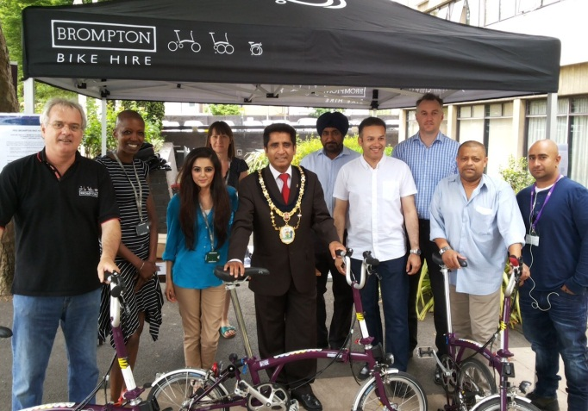

Borough Cycling Targets

The Borough Cycling targets are based on targets that have been identified in the 2015-17 LIP Programme. These targets will require annual monitoring and reporting and need to be reviewed at the next LIP funding stage.

The targets are linked to the cycling policies P1, P2, P3 and P4 and are listed below:

P1: Create a safer and better environment that supports cycling as an equal mode of transport

P2: Promote cycling as a convenient, safe, secure, inclusive and enjoyable activity

P3: To elevate cycling as an important sustainable mode of travel in the Borough

P4: To facilitate and to support bicycle ownership / access and secure parking

Appendix E shows the link between these targets to the Borough Cycling Policy and Objectives.

Delivering the Strategy

Borough Cycling Action Plan

The Borough Cycle Action Plan draws together on-going, planned and proposed actions to meet the cycling policy and targets. The action plan
includes actions relating to cycling that are funded and delivered through the various funding streams and programmes such as the Local Implementation Plan, Mayor’s Vision for Cycling and ad-hoc initiatives.

The Borough Cycle Action Plan is set out in Appendix F. The Action plan includes the following operational and good practice measures:

- Deliver free cycle training to children studying or residing in the borough

- Produce and update Bikeability travel maps including those specifically produced for schools

- Rolling out cycling promotions including campaigns targeted at BME and under-represented groups.

- Free cycle training for adults who live, work or study in the Borough including special needs cycle training

- Supporting Bike Clubs in high schools

- Deliver Learn to Balance and Ride sessions to support supplementary Bikeability training for children aged between 3 to 11 years

- Encourage cycling potential for women through the introduction of the Women’s Bike Club and Women’s Commuter Club

- Deliver tailored Bike Clubs in Special Education Needs (SEN) schools

- Try Cycling events

- Working with businesses to promote cycling, cycling champions and cycling provision in their premises

- Encouraging closer working with cycle groups and the private sector to promote cycling in the Borough

- Increasing cycle parking provision at and in close proximity to rail stations, schools and colleges

- Working with the Met Police, PCSOs and community groups to promote bike marking and registration service

- Introduce cycle infrastructure standards as part of the Council’s design standards

The Council will continue with the rolling out of cycle infrastructure improvement measures that have secured the necessary funding.

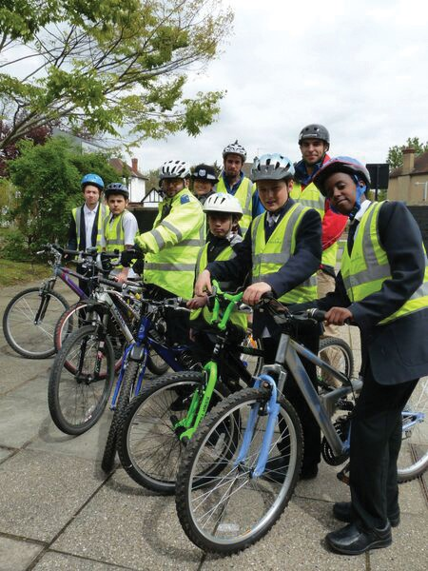

Borough cycling implementation plan

The implementation schedule for the Cycle Strategy Action Plan is attached in Appendix G. It includes Action Plans that have committed funding to 2017 as well as aspirational schemes which the Borough intends to progress with should funding be made available.

Monitoring of the Action Plan

The Borough’s Cycling Strategy will require continuous monitoring and benchmarking against targets that it has set to achieve. The Borough will allocate funding for monitoring progress of the Action Plan within the budgets for each scheme

We will monitor and review progress by:

- Undertaking manual count programmes at strategic sites in the Borough

- Using data/ counts of cycle and general traffic from TfL/ other sources

- Assessing frequency of cycling, cycle owner- ship as part of other surveys being carried out by the Council;

- Using the iTRACE system to monitor school and site travel plans;

- Using TfL casualty data;

- Using Metropolitan police data on cycle theft;

- Carrying out counts of parked bicycles at key locations;

- Using School Hands Up data on school cycling and out of school cycling by children; and

- Obtain feedback on the effectiveness of cycling activities such as led rides and Skyride

The monitoring plan of our cycling targets is set out in Appendix H.
The Council will produce a cycling monitoring report annually.

